**ADK PYTHON PRACTICAL ROLL NO.05**

**EXPERIMENT NO.1(B)**

**B] Enter the number from the user and depending on whether the number is**

**Even or odd,print out an appropriate message to the user.**

**CODE:**

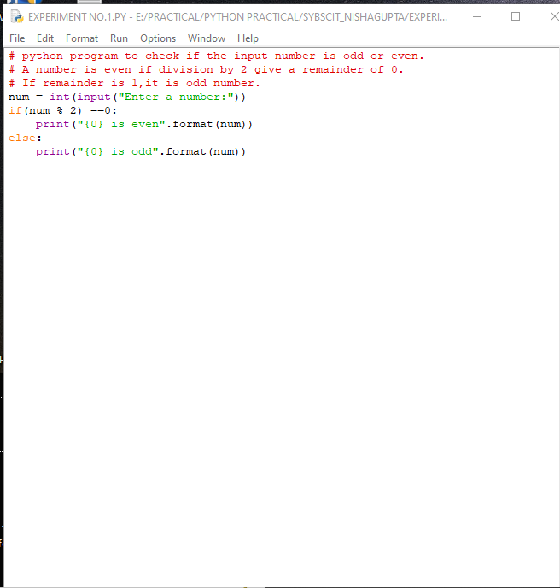

**OUTPUT:**

